

Relationships, sex and health education (RSHE) Policy

GEORGE STREET PRIMARY SCHOOL

“Believing in Every Child”

DRAFT

Approved by: |  | Date: September 2026
Last reviewed on: | September 2026
Next review due by: | September 2027
Contents
1. Aims 3
2. Statutory requirements 3
3. Policy development 3
4. Definition 4
5. Curriculum 4
6. Delivery of RSHE 4
7. Use of external organisations and curriculum materials 8
8. Roles and responsibilities 9
9. Parents’ right to withdraw 10
10. Training 10
11. Monitoring arrangements 10
Appendix 1: Curriculum map 11
Appendix 2: By the end of primary school pupils should know 14
Appendix 3: Parent/carer form requesting their child’s withdrawal from sex education within RSHE 22

1. Aims
The aims of relationships, sex and health education (RSHE) at our school are to:
- Provide a framework in which sensitive discussions can take place
- Prepare pupils for puberty, and give them an understanding of sexual development and the importance of health and hygiene
- Help pupils develop feelings of self-respect, confidence and empathy, and cultivate positive characteristics such as kindness and integrity
- Create a positive culture and promote healthy norms about relationships, including sexual relationships where relevant, and about health, including mental health
- Teach pupils the correct vocabulary to describe themselves and their bodies

2. Statutory requirements
As a maintained primary school, we must provide relationships education to all pupils under section 34 of the Children and Social Work Act 2017. We must also teach health education.
We are not required to provide sex education, but we do need to teach the elements of sex education contained in the science curriculum.
In teaching RSHE, we must have regard to guidance issued by the secretary of state, as outlined in section 403 of the Education Act 1996.
We also have regard to legal duties set out in:
- Sections 404 to 407 of the Education Act 1996
- Part 6, chapter 1 of the Equality Act 2010
- The Public Sector Equality Duty (PSED) (as set out in section 149 of the Equality Act 2010). This duty requires public bodies to have due regard to the need to eliminate discrimination, advance equality of opportunity and foster good relations between different people when carrying out their activities
At George Street Primary School, we teach RSHE as set out in this policy.

3. Policy development
This policy has been developed in consultation with staff, pupils and parents/carers. The consultation and policy development process involved the following steps:
- Review – a member of staff or working group pulled together all relevant information including relevant national and local guidance.

- Staff consultation – all school staff were given the opportunity to look at the policy and make recommendations.

- Parent/stakeholder consultation – parents/carers and any interested parties were invited to feedback on the policy.

- Pupil consultation – we investigated what exactly pupils want from their RSHE.

- Ratification – once amendments were made, the policy was shared with governors and ratified.

4. Definition
For the purpose of this policy:
Relationships and health education will:
- Teach the skills and knowledge that form the building blocks of all positive relationships
- Support children from the start of their education to grow into kind, caring adults who:
  - Have respect for others
  - Know how to keep themselves safe
  - Have emotional awareness
- Highlight the benefits and importance of physical activity, good nutrition, sufficient sleep and time spent outdoors
- Emphasise the relationship between physical health and mental wellbeing
- Aim to reduce stigma attached to health issues, in particular relating to mental health, and discourage the pejorative use of language related to ill health
- In year 6 we offer to teach the children about how babies are made using a video that is vetted by parents before sharing the information with the children in the summer term of each academic year.

5. Curriculum
Our RSHE curriculum is set out as per Appendices 1 and 2, but we may need to adapt it as and when necessary.
We have developed the curriculum in consultation with parents and carers, pupils and staff, and taking into account the age, developmental stage, needs (such as cultural and religious needs) and feelings of our pupils. If pupils ask questions outside the scope of this policy, teachers will respond in an appropriate manner so that pupils are fully informed and don’t seek answers online. Teaching will be developed to ensure the curriculum is accessible for pupils with SEND.
We will share all curriculum materials with parents and carers on request.

6. Delivery of RSHE
RSHE is taught within the personal, social, health and economic (PSHE) education curriculum. Biological aspects of RSHE are taught within the science curriculum, and other aspects are included in religious education (RE).
At George Street Primary School, we will make sure that:
- Core knowledge is sectioned into units of manageable size
- The required content is communicated to pupils clearly, in a carefully sequenced way and within a planned scheme of work
- Teaching includes sufficient and well-chosen opportunities and contexts for pupils to embed new knowledge, so that it can be used confidently in real-life situations
- “Over blocking” by the school’s filtering and monitoring system doesn’t lead to unreasonable restrictions as to what children can be taught

Through planned lessons in the curriculum, as well as through wider school activities, such as assemblies, children are able to develop their ideas, knowledge and skills gradually and appropriately. Teachers have the main responsibility for teaching about RSE in the classroom and they plan and liaise with other specialists, to ensure our pupils receive an up to date and balanced programme.
Relationships education focuses on teaching the skills and knowledge that form the building blocks of all positive relationships, supporting children from the start of their education to grow into kind, caring adults who have respect for others and know how to keep themselves and others safe, including:
- Families and people who care for me
- Caring friendships
- Respectful, kind relationships
- Online safety and awareness
- Being safe
Health education will:
- Highlight the benefits and importance of physical activity, good nutrition, sufficient sleep and time spent outdoors
- Emphasise the relationship between physical health and mental wellbeing

Sex Education at George Street Primary School
Although The Relationships Education, Relationship & Sex Education and Health Education (England) Regulations 2019, made Relationship Education compulsory in all primary schools, Sex education is currently not compulsory. However, the Department for Education continues to recommend that all primary schools should have a sex education programme tailored to the age and maturity of the pupils.
As set out in the guidance it is up to individual schools to determine whether they need to cover any additional content on sex education to meet the needs of their pupils. We, like many other schools already choose to teach some aspects of sex education and will continue to do so.

We recognise that some parents may be uncomfortable with the thought of their children receiving sex education in primary school. Equally, we recognise it is completely natural for children to have questions about sex, their bodies and to be curious about where they came from. In the age of information where children in primary school have access to the internet through mobile technology, we believe it is better that children receive age-appropriate answers from us than it being left to their peers or the internet.

In our school, sex education is an opportunity to answer children’s questions about where they came from, an opportunity to explore their own stories and to be clear about how a baby is conceived and formed as set out in human life cycle set out in the national curriculum for science.
Furthermore, it should ensure that all children are prepared for both the physical and emotional changes of puberty including menstruation. Children need to understand how both girls and boys bodies function and change as they grow into adults. We believe that sex education should allow children a safe space to ask the questions they may have without shame or judgement.

Evidence states that a graduated age-appropriate curriculum is the best way of preventing the topic of sex, reproduction and private body parts becoming taboo and children from becoming embarrassed by the topic. We believe it is the duty of our school to give our young people from Early Years right through to Year 6 the learning that will enable them to live safe, fulfilled and healthy lives. This includes ensuring that they have the skills to keep themselves safe from harm and develop positive and healthy relationships, free from exploitation pressure or abuse.

At George Street Primary School, Primary Sex Education will focus on:
- Sexual difference and naming body parts
- Preparing boys and girls for the changes that adolescence brings
- Exploring the impact of puberty on the body and the importance of physical hygiene
- Understanding that menstruation and wet dreams are a normal part of growing up
- How a baby is conceived and born, considered in the context of relationships
- Answering each other’s questions about sex and relationships with confidence and knowing where to find support and advice

In Year 6, the children watch a series of DVDs on personal hygiene, the human reproductive system and puberty, including relationships and responsibilities. Parents are invited to watch the content relating to sex education to be used prior to delivery, in order for parents to make an informed choice as to whether they would like their child to be included in this lesson or not.

Throughout each year group we will use appropriate material to assist learning, such as:
- Diagrams
- Presentations
- Videos
- Books
- Games
- Discussions and practical activities

Teachers will make sure that all pupils’ views are listened to, and will encourage them to ask questions and engage in discussion. Teachers will answer questions sensitively, honestly and appropriately for the age of the pupils.
The programme will be designed to focus on boys as much as girls, and activities will be planned to make sure both are actively involved.
Pupils will be introduced to protective and preventative content in a way that does not cause unreasonable alarm and does not appear to normalise risky behaviours or activities. The school will make sure that all teaching and materials are appropriate for the ages and needs of the pupils including any additional needs, such as special educational needs and disabilities (SEND).
At all points of delivery of the curriculum, the school will consult parents and carers, and their views will be valued. What will be taught and how will be planned in conjunction with parents and carers.
For more information about our RSHE curriculum, see Appendices 1 and 2

We may amend our curriculum content to respond to the needs and context of our pupils, to discuss issues affecting them in an age-appropriate manner. We will inform parents and carers of any deviation from our published policy in advance, and share any relevant materials on request.
These areas of learning are taught within the context of family life, taking care to make sure that there is no stigmatisation of children based on their home circumstances (i.e. families can include single-parent families, same-sex parents, families headed by grandparents, adoptive parents and foster parents among other structures), along with reflecting sensitively that some children may have a different structure of support around them (for example, looked-after children, young carers or kinship carers).
Across our school, we will also be mindful of the law and legal requirements, taking care not to condone or encourage illegal activity, such as violent action against people, criminal damage to property or hate crime.
  - Inclusivity
We will teach about these topics in a manner that:
- Considers how a diverse range of pupils will relate to them
- Is accessible to pupils with SEND
- Is sensitive to all pupils’ experiences
- During lessons, makes pupils feel:
  - Safe and supported
  - Able to engage with the key messages
We will also:
- Make sure that pupils learn about these topics in an environment that’s appropriate for them, for example in:
  - A whole-class setting
  - Small groups or targeted sessions
  - 1-to-1 discussions
  - Digital formats
- Give careful consideration to the level of differentiation needed

  - Use of resources
We will consider whether any resources we plan to use:
- Are aligned with the teaching requirements set out in the statutory RSHE guidance
- Would support pupils in applying their knowledge in different contexts and settings
- Are age-appropriate, given the age and maturity of the pupils
- Are evidence-based and contain robust facts and statistics
- Fit into our curriculum plan
- Are from credible sources
- Are compatible with effective teaching approaches
- Are sensitive to pupils’ experiences and won’t provoke distress
We will make sure that when we consult parents/carers we provide a representative sample of the resources that the school plans to use.
We will ensure that parents/carers are able to view all curriculum materials used to teach RSHE on request.
Parents/carers are not able to veto curriculum content.
We will comply with any applicable copyright laws when sharing resources with parents or carers, and will include a statement that parents agree to as a condition of access that the content should not be copied or shared further except as authorised under copyright law.

7. Use of external organisations and curriculum materials
Whilst the school may work with external organisations to deliver the curriculum, it remains responsible for the content and the way in which pupils are taught.
We will make sure that any agency and any materials used are accurate, age and stage-appropriate, and unbiased and in line with our legal duties around political impartiality.
We will:
- Make appropriate checks and engage with external agencies to make sure that their approach to teaching about RSHE is balanced, and it and the resources they intend to use:
  - Are age-appropriate
  - Are in line with pupils’ developmental stage
  - Are accessible for all pupils, including those with SEND
  - Are sensitive to pupils’ needs
  - Comply with:
    - This policy
    - The Teachers’ Standards
    - The Equality Act 2010
    - The Human Rights Act 1998
    - The Education Act 1996
- Only work with external agencies where we have full confidence in the agency, its approach and the resources it uses
- Make sure that any speakers and resources meet the intended outcome of the relevant part of the curriculum
- Review any case-study materials and look for feedback from other people the agency has worked with
- Be clear on:
  - What they’re going to say
  - Their position on the issues to be discussed
- Ask to see in advance any materials and lesson plans that the agency may use
- Know the named individuals who will be there, check the credentials of the visitor and/or visiting organisation, and follow our usual safeguarding procedures for these people
- Make sure the visitor understands and agrees in advance:
  - How confidentiality will work in any lesson
  - How safeguarding reports should be dealt with, in line with our school policies
- Conduct a basic online search and address anything that may be of concern to us, or to parents and carers
- Check the agency’s protocol for taking pictures or using any personal data they might get from a session
- Remind teachers that they can say “no” or, in extreme cases, stop a session
- Make sure that the teacher is in the room during any sessions with external speakers
- Inform all external organisations that the school is legally obliged to share all content with parents and carers
- Share all external materials with parents and carers
- Consult parents/carers on the content of external resources on the topic of biological sex and gender reassignment in advance and make all materials available to them on request
- Avoid materials that use cartoons or diagrams that oversimplify the topics of biological sex and gender reassignment, that could be interpreted as being aimed at younger children, or that perpetuate stereotypes or encourage pupils to question their gender
We won’t, under any circumstances:
- Work with external agencies that take or promote extreme political positions
- Use materials produced by such agencies, even if the material itself is not extreme
- Work with agencies who don’t allow their material to be shared with parents and carers. The school will communicate to agencies that it is legally obliged to have regard to the expectation that all content can be shared with parents and carers

8. Roles and responsibilities
8.1 The governing board
The governing board will approve the RSHE policy, and hold the headteacher to account for its implementation.
The governing board will ensure that:
- All pupils make progress in achieving the expected educational outcomes • teaching is accessible to all pupils with SEND
- Curriculum content and teaching materials are aligned with the guidance
- Clear information is provided for parents on the subject content, teaching materials and external providers, and on the right to request that their child is withdrawn from sex education
8.2 The headteacher
The headteacher is responsible for making sure that RSHE is taught consistently across the school, for sharing all resources and materials with parents and carers, and for managing requests to withdraw pupils from non-statutory components of RSHE (see section 9).
8.3 Staff
Staff are responsible for:
- Delivering RSHE in a way that is sensitive, high-quality and appropriate for each year group
- Modelling positive attitudes to RSHE
- Monitoring progress
- Responding to the needs of individual pupils
- Responding appropriately to pupils whose parents/carers wish them to be withdrawn from the non-statutory components of RSHE
- Modelling positive behaviour and avoiding language that might perpetuate harmful stereotypes, and being conscious of everyday sexism, misogyny/misandry, homophobia, biphoboia, sexual violence/harassment, derogatory behaviour and stereotypes
- Where misogynistic ideas are expressed at school, challenging the ideas, rather than the person expressing them
- Reporting any safeguarding concerns or disclosures that pupils may make as a result of the subject content to the school’s designated safeguarding lead (DSL) [Mrs A Hughes]
Staff do not have the right to opt out of teaching RSHE. Staff who have concerns about teaching RSHE are encouraged to discuss this with the headteacher.

Headteacher: Mrs A Hughes
PSHE, RSE and Health Education Subject Leader: Mrs E Achilleos-Irvine

8.4 Pupils
Pupils are expected to engage fully in RSHE and, when discussing issues related to RSHE, treat others with respect and sensitivity.

9. Parents’ right to withdraw

Parents/carers do not have the right to withdraw their child from relationships and health education.
Parents retain the right to request their child is removed from some or all of the elements of sex education which go beyond the national curriculum for science and the statutory RSHE. Maintained schools are required to teach about the main external body parts and changes to the human body as it grows from birth to old age, including puberty within the Science curriculum and Health Education statutory guidance; there is no right to withdraw from this.
Parents have the right to withdraw from the further sex education programme that takes place in year 6. Letters are sent out in advance to notify parents and carers in Y6 when this further Sex Education is scheduled to take place. Parents and carers are given the opportunity to preview any DVD/materials that will be shown to children.
We also highlight that whilst parents have the right to withdraw their child from these lessons, they do not have the right to withdraw other children from receiving these lessons. We believe it is better for children to hear from safe adults than to hear second hand, possibly inaccurately from peers or less reliable sources. It is our hope that the school’s programme for RSE and Health Education will complement and build in co-operation with parents.
Parents/carers have the right to withdraw their child from the non-statutory components of sex education within RSHE.
Requests for withdrawal should be put in writing using the form found in Appendix 3 of this policy and addressed to the headteacher.
Alternative schoolwork will be given to pupils who are withdrawn from sex education.

10. Training
Staff are trained on the delivery of RSHE as part of their induction and it is included in our continuing professional development calendar.
The headteacher will also invite visitors from outside the school, such as school nurses or sexual health professionals, to provide support and training to staff teaching RSHE.

11. Monitoring arrangements
The delivery of RSHE is monitored by the Headteacher and Subject Leader through planning scrutinies, learning walks, lesson observations, books looks and pupil voice etc.
Pupils’ development in RSHE is monitored by class teachers as part of our internal assessment systems.
This policy will be reviewed by the Headteacher and PSHE lead every year. At every review, the policy will be approved by the Headteacher and Governing body.

Appendix 1: Curriculum map
Relationships, sex and health education curriculum map

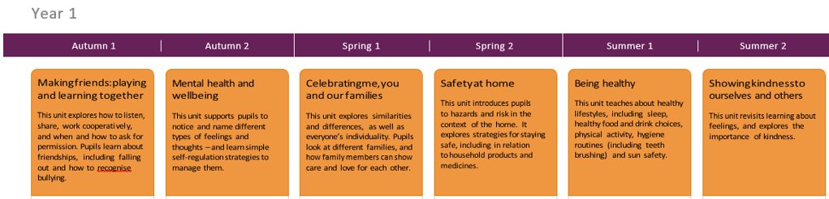
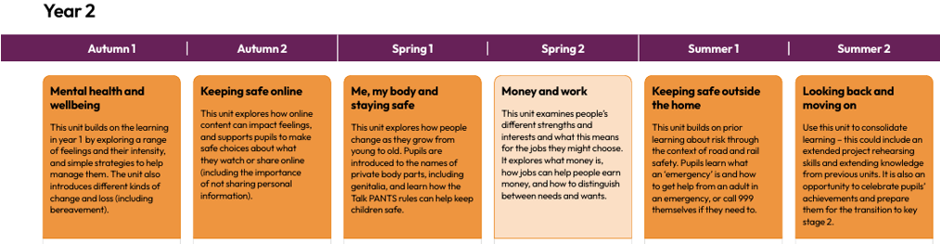
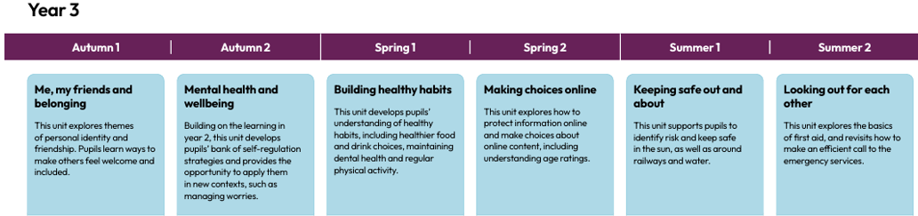
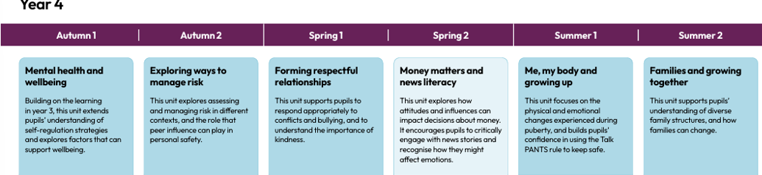
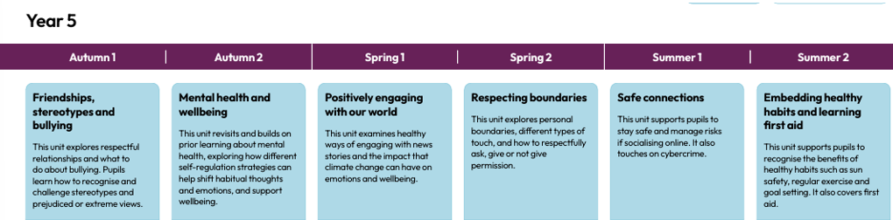
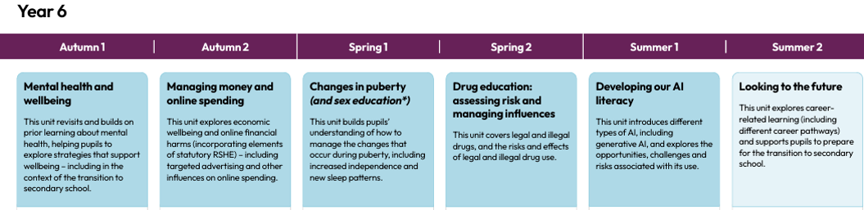

Appendix 2: By the end of primary school pupils should know
Topic | Pupils should know
Families and people who care for me | - That families are important for children growing up because they can give love, security and stability  - The characteristics of safe and happy family life, such as: commitment to each other, including in times of difficulty, protection and care for children and other family members, the importance of spending time together and sharing each other’s lives  - That other children’s families, either in school or in the wider world, sometimes look different from their own, but they should respect those differences and know that other families are also characterised by love and care  - That stable, caring relationships are at the heart of safe and happy families, and are important for children’s security as they grow up  - That marriage and civil partnerships represent a formal and legally recognised commitment of 2 people to each other which is intended to be lifelong  - How to recognise if family relationships are making them feel unhappy or unsafe, and how to seek help or advice from others if needed
Caring friendships | - How important friendships are in making us feel happy and secure, and how people choose and make friends  - The characteristics of friendships that lead to happiness and security, including: mutual respect, truthfulness, trust and trustworthiness, loyalty, kindness, generosity, sharing interests and experiences and support with problems and difficulties  - That healthy, caring and kind friendships are positive and welcoming towards others, and do not make others feel lonely or excluded. Pupils should learn skills for developing caring, kind friendships  - That not every child will have the friends they would like at all times, that most people feel lonely sometimes, and that there is no shame in feeling lonely or talking about it  - That most friendships have ups and downs, and that these can often be worked through so that the friendship is repaired or even strengthened  - About managing conflict with kindness and respect, and that violence is never right  - How to recognise when a friendship is making them feel unhappy or uncomfortable, and how to seek help or advice from others, if needed
Respectful, kind relationships | - How to pay attention to the needs and preferences of others, including in families and friendships. Pupils should be encouraged to discuss how we can balance the needs and wishes of different people in relationships, and why this can be complicated  - The importance of setting and respecting healthy boundaries in all relationships with friends, family, peers and adults  - How to communicate effectively and manage conflict with kindness and respect: how to be assertive and express needs and boundaries and manage feelings, including disappointment and frustration  - That they can expect to be treated with respect by others and the importance of respecting others, including those who are different (for example: physically or in character, personality or background), or make different choices, or have different preferences or beliefs  - The practical steps they can take in a range of different contexts to improve or support their relationships  - The conventions of courtesy and manners  - The importance of self-respect and how this links to their own happiness. They should have opportunities to consider issues like how they foster their own self-esteem and build a strong sense of their own identity, including through developing skills and interests  - Pupils should have opportunities to discuss the difference between being assertive and being controlling, and the difference between being kind to other people and neglecting your own needs  - About different types of bullying (including online bullying), the impact of bullying, responsibilities of bystanders (primarily reporting bullying to an adult) and how to get help  - How to seek help when needed, including when they are concerned about violence, harm, or when they are unsure who to trust  - What a stereotype is, and how stereotypes can be unfair, negative or destructive or lead to bullying and how to challenge a stereotype
Online safety and awareness | - How to critically evaluate their online relationships and sources of information, including awareness of the risks associated with people they have never met  - That people sometimes behave differently online, including by pretending to be someone they are not and/or pretending to be a child, and that this can lead to dangerous situations  - That people should be respectful in online interactions, and that the same principles apply to online relationships as to face-to face relationships, including the importance of respect for others online, including when we are anonymous. For example, the importance of avoiding putting pressure on others to share information and images online, and strategies for resisting peer pressure.  - The rules and principles for keeping safe online, how to recognise risks, harmful content and contact, and how to report them  - That there is a minimum age for joining most social media sites which protects children from inappropriate content or unsafe content with older social media users, who may be strangers, including other children and adults  - That it’s important to be cautious about sharing any information about themselves online, and how to use privacy and location settings to protect their information online  - How to critically consider their online friendships and sources of information, including awareness of the risks associated with people they have never met  - How information and data is shared and used online, including where pictures or words might be circulated  - Online risks, including that any material provided online might be circulated, and that once a picture or words has been circulated there is no way of deleting it everywhere and no control over where it ends up  - That the internet contains a lot of content that can be inappropriate and upsetting for children, and where to go for advice and support when they feel worried or concerned about something they have seen or engaged with online
Being safe | - What sorts of boundaries are appropriate in friendships with peers and others (including online). This can include learning about boundaries in play and in negotiations about space, toys, books and resources, for example  - About the concept of privacy and the implications of it for both children and adults, including that it’s not always right to keep secrets if they relate to being safe  - That each person’s body belongs to them, and the differences between appropriate and inappropriate or unsafe contact, including physical contact  - How to respond safely and appropriately to adults they may encounter (in all contexts, including online) including those they do and don’t know  - How to recognise when a relationship is harmful or dangerous, including skills for recognising who to trust and who not to trust  - How to report abuse, concerns about something seen online or experienced in real life, or feelings of being unsafe or feeling bad about any adult, and the vocabulary and confidence needed to do so  - How to ask for advice or help for themselves or others, and to keep trying until they are heard  - Where to get advice, for example from their family, school and/or other sources
General wellbeing | - The health, wellbeing and happiness benefits of physical activity, time outdoors, and helping others  - Simple self-care techniques, including the importance of rest, time spent with friends and family, as well as hobbies, interests and community participation  - The importance of promoting general wellbeing and physical health  - The range of scale of emotions that they might experience in different situations (e.g. happiness, sadness, anger, fear, surprise, nervousness) and that worrying and feeling down are normal, affect everyone at different times, and are not in themselves a sign of a mental health condition  - How to recognise feelings and use varied vocabulary to talk about their own and others’ feelings  - How to judge whether what they are feeling and how they are behaving is appropriate and proportionate  - That isolation and loneliness can affect children, and the benefits of seeking support  - That bullying (including cyberbullying) has a negative and often lasting impact on mental wellbeing and how to seek help for themselves or others  - That change and loss, including bereavement, can provoke a range of feelings, that grief is a natural response to bereavement, and that everyone grieves differently  - Where and how to seek support (including recognising the triggers for seeking support), including who to speak to in school if they are worried about their own or someone else’s mental wellbeing or ability to control their emotions (including issues arising online)  - That it is common to experience mental health problems, and early support can help
Wellbeing online | - That for almost everyone the internet is an integral part of life  - How to think about positive and negative aspects of the internet  - How online relationships can complement and support meaningful in-person relationships, but also how they might be in tension, and the reasons why online relationships are unlikely to be a good substitute for high quality in-person relationships, looking at the pros and cons of different ways of using online connection  - The benefits of limiting time spent online, the risks of excessive time spent on electronic devices and the impact of positive and negative content online on their own and others’ mental and physical wellbeing  - How to consider the impact of their online behaviour on others, and how to recognise and display respectful behaviour online  - Why social media, some apps, computer games and online gaming, including gambling sites, are age restricted  - The risks relating to online gaming, video game monetisation, scams, fraud and other financial harms, and that gaming can become addictive  - How to take a critical approach to what they see and read online and make responsible decisions about which content, including content on social media and apps, is appropriate for them  - That abuse, bullying and harassment can take place online and that this can impact wellbeing  - How to seek support from trusted adults  - How to understand the information they find online, including from search engines, and know how information is selected and targeted  - That they have rights in relation to sharing personal data, privacy and consent  - Where and how to report concerns and get support with issues online
Physical health and fitness | - The characteristics and mental and physical benefits of an active lifestyle  - The importance of building regular physical activity into daily and weekly routines and how to achieve this; for example, walking or cycling to school, a daily active mile or other forms of regular, moderate and/or vigorous physical activity  - The risks associated with an inactive lifestyle, including obesity  - How and when to seek support including which adults to speak to in school if they are worried about their health
Healthy eating | - What constitutes a healthy diet (including understanding calories and other nutritional content)  - Understanding the importance of a healthy relationship with food  - The principles of planning and preparing a range of healthy meals  - The characteristics of a poor diet and risks associated with unhealthy eating (including, for example, obesity and tooth decay) and other behaviours (e.g. the impact of alcohol on diet or health)
Drugs, alcohol, tobacco and vaping | - The facts about legal and illegal harmful substances and associated risks, including smoking, vaping, alcohol use and drug-taking. This should include the risks of nicotine addiction, which are also caused by other nicotine products such as nicotine pouches
Health protection and prevention | - How to recognise early signs of physical illness, such as weight loss, or unexplained changes to the body  - About safe and unsafe exposure to the sun, and how to reduce the risk of sun damage, including skin cancer  - The importance of sufficient good quality sleep for health, the amount of sleep recommended for their age, and practical steps for improving sleep, such as not using screens in the bedroom. The impact of poor sleep on weight, mood and ability to learn  - About dental health and the benefits of good oral hygiene, including brushing teeth twice a day with fluoride toothpaste, cleaning between teeth, and regular checkups at the dentist  - About personal hygiene and germs including bacteria, viruses, how they are spread and treated, and the importance of handwashing  - The facts and scientific evidence relating to vaccination and immunisation. The introduction of topics relating to vaccination and immunisation should be aligned with when vaccinations are offered to pupils
Personal safety | - About hazards (including fire risks) that may cause harm, injury or risk and ways to reduce risks  - How to recognise risk and keep safe around roads, railways, including level crossings, and water, including the water safety code
Basic first aid | - How to make a clear and efficient call to emergency services if necessary, including the importance of reporting incidents rather than filming them  - Concepts of basic first aid, for example dealing with common injuries and ailments, including head injuries
Developing bodies | - About growth and other ways the body can change and develop, particularly during adolescence. This topic should include the human lifecycle, and puberty should be discussed as a stage in this process  - The correct names of body parts, including the penis, vulva, vagina, testicles, scrotum, nipples. That all of these parts of the body are private and have skills to understand and express their own boundaries around these body parts  - The facts about the menstrual cycle, including physical and emotional changes (while the average age of the onset of menstruation is 12, periods can start at 8, so covering this topic before girls’ periods start will help them understand what to expect and avoid distress)

Appendix 3: Parent/carer form requesting their child’s withdrawal from sex education within RSHE
To be completed by parents/CARERS
Name of child |  | Class
Name of parent/carer |  | Date
Reason for withdrawing from sex education within relationships and sex education
Any other information you would like the school to consider
Parent/carer signature

To be completed by the school
Agreed actions from discussion with parents/carers

