English
History

Maths

Reading
Children will continue to develop their fluency in reading through the phonics scheme, Read Write Inc. Pupils will rehearse and secure sounds, focussing on simple retrieval and inference skills from a book. Whilst reading both fiction and non-fiction texts, we will be discussing our thoughts and answering varied types of comprehension questions. In addition, pupils will build on their inference skills through class texts and shared reading opportunities.

Writing

To start off the year, we will be reviewing our sentence writing skills. A big focus for year two this term is to begin to use coordinating conjunctions (and, but, or). We will be exploring writing different narratives, recounts and poetry. The children will be using our history learning of the Great Fire of London and the book ‘Toby and the Great Fire of London’ to support us in making our very own diary entries.

Recommended Books
Into the Forest - Anthony Browne
Once There Were Giants - Martin Waddell
Ahmed and the Feather Girl - Jane Ray

Initially, maths learning will focus heavily on place value.

Pupils will begin securing their fluency to twenty and learn the value of digits within numbers using different practical resources. Children will learn how to count on and back in ones and tens from any number, recognising patterns. In addition, they will represent, order and compare numbers to one hundred and learn how to estimate appropriately.

Later in the term, pupils will explore addition and subtraction mental methods for one- and two-digit numbers. The children will also learn how to find unknown quantities of number using different visual representations. Finally, the class will move onto learning about money; making combinations and finding change as well as using different scales to measure.

Along with general maths lessons, pupils will also have daily maths mastery sessions that will help reactivate previous learning as well as retain new learning.

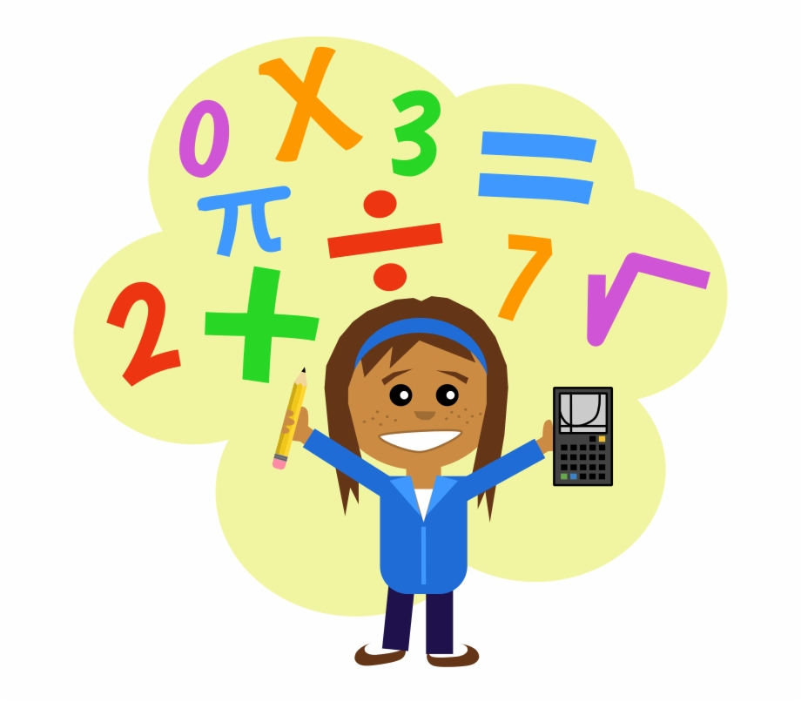
A Step Back in Time

Over the course of the term, children will be learning about The Great Fire of London.

The class will begin their journey in 1666 when ‘The Great Fire of London’ struck the capital. We will begin by considering the differences between life today and life in the 1600s.

Pupils will then discover who and what started the deadly fire all those years ago. The children will learn why the fire spread so quickly and what changes were put in place to prevent a large-scale fire from happening again in the future.

Later in the term, the children will be identifying the impact the fire had on London and other people’s lives. The children will look at different sources, including Samuel Peyps diary. This will support the children’s understanding of this major event.

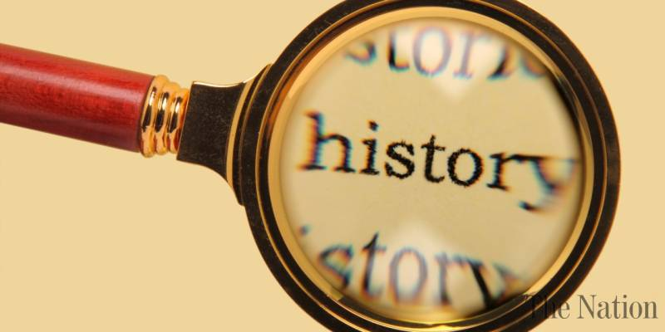

Important Dates
Physical Education
Science
PE will be on a Wednesday; pupils will be working on:
- Attack, defend and shoot games.
- Gymnastics.
Return to school – Thursday 4th September

Parents evening – Wednesday 22nd and Thursday 23rd October

October half term - Monday 27th October – Friday 31st October
Back to school - Monday 3rd November

In Science our topic will be ‘Uses of Everyday Materials’
- Children will learn to identify and compare the suitability of a variety of everyday materials including wood, metal, plastic, glass, brick, rock, paper and cardboard for particular uses.
- Pupils will find out how the shapes of solid objects made from some materials can be changed by squashing, bending, twisting and stretching.
- Children will carry out their own scientific based enquiries.

Music

In Music children will be:

- Storytelling, exploring rhythmic patterns and sounds.
Please can children continue to read at least four times a week at home and bring their books and reading diary filled in to school. Books are changed on a Friday.
Homework is set on a Friday and due in on the following Thursday on Google Classroom.

- Create your own nature-based artwork using natural materials from the garden or Local Park.

Reading Target and Home Learning

In PSHE our topic will be ‘Relationships’

- What makes a good friend?
- What is bullying?

In Art children will be learning to:
- Choose when to use lines of different sizes and thickness in drawing.
- Colour neatly, paying attention to the directions of strokes.
- Use different tones using coloured pencils with a piece of work.
RE

In RE children will be learning to:
- Retell the story of creation.
- Recognise that ‘creation’ is the beginning of the ‘big story’ of the Bible.
- Think, talk and ask questions about living in an amazing world.
Art

Suggestions for days out/activities
Computing
In Computing children will be:

- Learning how to keep themselves safe whilst online.
- Learning how to search effectively on the internet.
PSHE

